Properties of Addition

Property | Definition | Example
Additive Identity  Element | The sum of a number and  zero is that number.
Commutative Property

Associative Property

Additive Inverses  (opposites) | The sum of a number and its opposite is 0.
Closure Property | The sum of any two numbers is a unique real number.

Properties of Multiplication
Property | Definition | Example
Multiplicative Identity  Element | The product of a number and  one is that number.
Commutative Property

Associative Property

Multiplicative Inverses (Reciprocals) | When the product of two numbers is one.
Multiplication Property of Zero

Closure Property | The product of any two numbers is a unique real number

Lesson 7A: Algebraic Expressions—The Commutative and Associative Properties

Classwork
Four Properties of Arithmetic:
The Commutative Property of Addition: If $a$ and $b$ are real numbers, then $a+b=b+a$.
The Associative Property of Addition: If $a, b,$ and $c$ are real numbers, then $\left(a+b\right)+c=a+(b+c)$
The Commutative Property of Multiplication: If $a$ and $b$ are real numbers, then $a×b=b×a$.
The Associative Property of Multiplication: If $a, b,$ and $c$ are real numbers, then $\left(ab\right)c=a(bc)$.

Exercise 1
Viewing the diagram below from two different perspectives illustrates that $\left(3+4\right)+2$ equals
$2+(4+3)$.

Is it true for all real numbers $x, y$and $z$ that $\left(x+y\right)+z$ should equal $\left(z+y\right)+x$?
(Note: The direct application of the Associative Property of Addition only gives$\left(x+y\right)+z=x+(y+z)$.)

Exercise 2
Draw a flow diagram and use it to prove that $\left(xy\right)z=\left(zy\right)x$ for all real numbers $x, y,$ and $z$.

Exercise 3
Use these abbreviations for the properties of real numbers and complete the flow diagram.
$C_{+}$ for the commutative property of addition
$C_{×}$ for the commutative property of multiplication
$A_{+}$ for the associative property of addition
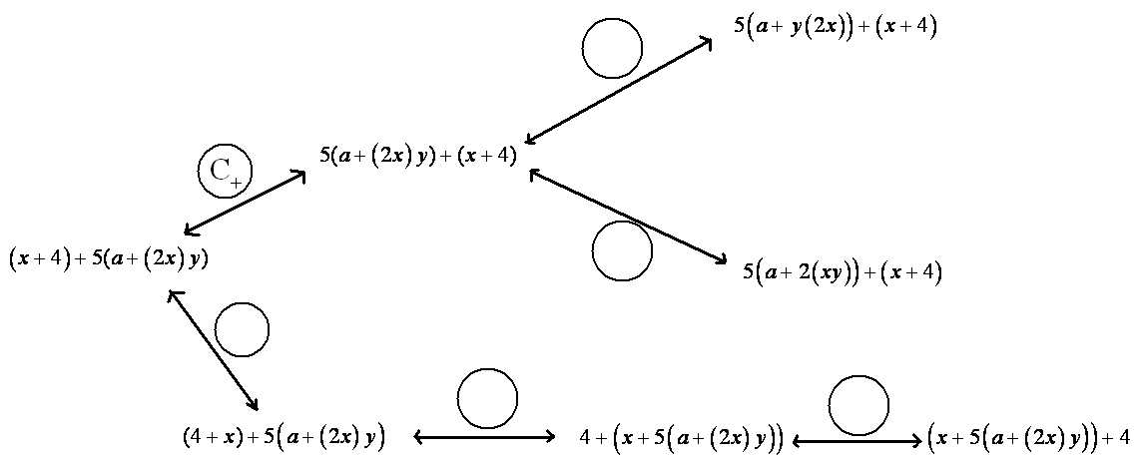
$A_{×}$ for the associative property of multiplication

Exercise 4
Let $a, b, c,$and $d$be real numbers. Fill in the missing term of the following diagram to show that $\left(\left(a+b\right)+c\right)+d$ is sure to equal $a+\left(b+\left(c+d\right)\right)$.

Important Definitions
NUMERICAL SYMBOL: A numerical symbol is a symbol that represents a specific number.
For example, $0, 1, 2, 3,\frac{2}{3} ,-3, -124.122, π, e$ are numerical symbols used to represent specific points on the real number line.
VARIABLE SYMBOL: A variable symbol is a symbol that is a placeholder for a number.
It is possible that a question may restrict the type of number that a placeholder might permit, e.g., integers only or positive real number.
ALGEBRAIC EXPRESSION: An algebraic expression is either
- a numerical symbol or a variable symbol, or
- the result of placing previously generated algebraic expressions into the two blanks of one of the four operators $((__)+(__), (__)-(__), (__)×(__), (__)÷(__))$ or into the base blank of an exponentiation with exponent that is a rational number.

Two algebraic expressions are equivalent if we can convert one expression into the other by repeatedly applying the Commutative, Associative, and Distributive Properties and the properties of rational exponents to components of the first expression.

NUMERICAL EXPRESSION: A numerical expression is an algebraic expression that contains only numerical symbols (no variable symbols), which evaluate to a single number.
The expression, $3÷0$, is not a numerical expression.
EQUIVALENT NUMERICAL EXPRESSIONS: Two numerical expressions are equivalent if they evaluate to the same number.
Note that $1+2+3$ and $1×2×3$, for example, are equivalent numerical expressions (they are both $6$) but $a+b+c$ and $a×b×c$ are not equivalent expressions.

Lesson Summary
The Commutative and Associative Properties represent key beliefs about the arithmetic of real numbers. These properties can be applied to algebraic expressions using variables that represent real numbers.
Two algebraic expressions are equivalent if we can convert one expression into the other by repeatedly applying the Commutative, Associative, and Distributive Properties and the properties of rational exponents to components of the first expression.

Problem Set

- The following portion of a flow diagram shows that the expression $ab+cd$ is equivalent to the expression $dc+ba$.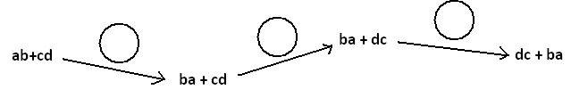

Fill in each circle with the appropriate symbol: Either $C_{+}$ (for the “Commutative Property of Addition”) or $C_{×}$ (for the “Commutative Property of Multiplication”).

- Fill in the blanks of this proof showing that $(w+5)(w+2)$ is equivalent $w^{2}+7w+10$. Write either “Commutative Property,” “Associative Property,” or “Distributive Property” in each blank.

$(w+5)(w+2)$ $=\left(w+5\right)w+(w+5)×2$

$=w\left(w+5\right)+(w+5)×2$

$=w\left(w+5\right)+2(w+5)$

$=w^{2}+w×5+2(w+5)$

$=w^{2}+5w+2(w+5)$

$=w^{2}+5w+2w+10$

$=w^{2}+(5w+2w)+10$

$=w^{2}+7w+10$ ____________________________

- What is a quick way to see that the value of the sum $53+18+47+82$ is $200$?

- Fill in each circle of the following flow diagram with one of the letters: C for Commutative Property (for either addition or multiplication), A for Associative Property (for either addition or multiplication), or D for Distributive Property.
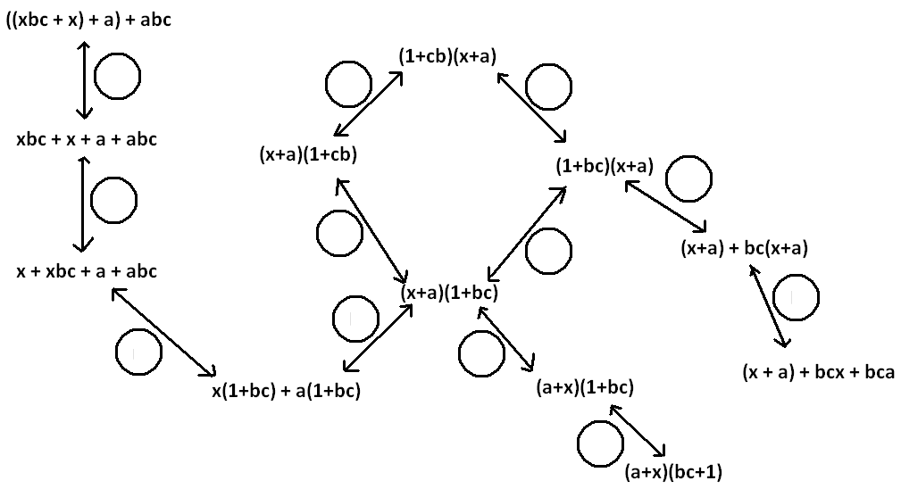

- The following is a proof of the algebraic equivalency of ${\left(2x\right)}^{3}$ and $8x^{3}$. Fill in each of the blanks with either the statement “Commutative Property” or “Associative Property.”

${\left(2x\right)}^{3}=2x∙2x∙2x$ Power to a Power___________

$=2\left(x×2\right)\left(x×2\right)x$ _________________________

$=2\left(2x\right)\left(2x\right)x$ _________________________

$=2∙2\left(x×2\right)x∙x$ _________________________

$=2∙2\left(2x\right)x∙x$ _________________________

$=(2∙2∙2)(x∙x∙x)$_________________________

$=8x^{3}$

- Write a mathematical proof of the algebraic equivalency of ${\left(ab\right)}^{2}$ and $a^{2}{b }^{2}$. (I provided a start for you there are three more steps to the conclusion)

${ \left(ab\right)}^{2}=\left(ab\right)\left(ab\right)$ ________________________________

- a. Suppose we are to play the $4$-number game with the symbols a, b, c, and d to represent numbers, each used at most once, combined by the operation of addition ONLY. If we acknowledge that parentheses are not needed, show there are essentially only $15$ expressions one can write.

b. How many answers are there for the multiplication ONLY version of this game?

- Write a mathematical proof to show that $(x+a)(x+b)$ is equivalent to $x^{2}+ax+bx+ab$.

Lesson 7A: Operations on Algebraic Expressions
Recall the following rules of exponents:
Product of  Powers | For any number a, and all integers m and n,  a^{m} ⋅ a^{n} = a^{m+n}
Power of  a Power | For any number a, and all integers m and n,  (a^{m})^{n} = a^{mn}
Power of  a Product | For all numbers a and b, and any integer m,  (ab)^{m} = a^{m}b^{m}
Power of  a Monomial | For all numbers a and b, and all integers m, n, and p,  (a^{m}b^{n})^{p} = a^{mp}b^{np}
Quotient of  Powers | For all integers m and n, and any nonzero number a,  a^{m} ÷ a^{n} = a^{m - n}
Zero  Exponent | For any nonzero number a,  a⁰ = 1
Negative  Exponents | For any nonzero number a and any integer n,  a^{-n} = 1  a^{n}

Study the examples below.

(8³)⁵ = (8³)(8³)(8³)(8³)(8³) product of powers (y⁷)³ = (y⁷)(y⁷)(y⁷)
= 8³ ⁺ ³ ⁺ ³⁺ ³ ⁺ ³ = y⁷ ⁺ ⁷ ⁺ ⁷
= 8¹⁵ = y²¹

8⁵ = (8 )(8)(8)(8)(8) y³ = _yyy_ = 1 or y⁻⁴
8³ (8)(8)(8) y⁷ yyyyyyy y⁴
= 8²

A Monomial is in Simplest Form when:
- There are no powers of powers
- Each base appears once
- All fractions are in simplest form
- No negative exponents

Simplify each expression

a²a³ = a²a⁴ = a²a⁵ = a⁴a⁷a =

(3c²)(2c³) = 5⁴⋅5⁷ = (xy⁴)(x²x³) = (8y⁶)(9y⁷) =

(-5a⁴)(6a) = (2x⁴)(4x³y²)(-3xy³) = (a⁴)²(b⁷)²(c)³ =

(6³)⁵ = (z²y³)² = (-2a²bc)³ =

(-6 • 5)² = (4xy)³ = (3x⁴)² • x⁵ = (-9)(-9z⁵)² =

Dividing Monomials
y⁴ ÷ y¹ z³ ÷ z² x³ ÷ x³

10⁵ ÷ 10³ 25a⁵ ÷ 5a² x³ ÷ x⁴

Problem Set

Write the expression as a single power of the base.

1. 4² • 4³ 2. (-3)²(-3) 3. x • x² 4. a²a³a⁴

5. (4²)³ 6. [(-3)⁵]² 7. (a²)⁵ 8. (x³)³

Simplify the expressions.

1. (-3 • 2)² 2. (2 • 4)³ 3. (2w)⁶ 4. (4y²z)³

Write the expression as a single power of the base.

1. a²a³ = 2. (c²c³)³ = 3. (x)(x³) = 4. 5⁴⋅5⁷ =

5. (y⁶)(y⁷) = 6. (-5)⁴(-5)² = 7. x⁴x³x = 8. (a²)² =

Complete the statement.

1. w⁷w? = w¹⁰ 2. (7?)⁵ = 7¹⁵ 3. [(-2)³]² = -2?

Transform each given expression into an equivalent one with a positive exponent

1. 4⁻³ 2. 6(3⁻³) 3. 10⁻¹ 4. 2⁷ ÷ 2⁻³

5. 1 6. 3⁻⁶ ÷ 3⁻² 7. (5)⁻² 8. (x⁴)⁻³
2⁻⁵

9. 24y⁴ 10. -65z³ 11. -21a⁵b⁴ 12. 12y²z²
6y 13z² -3a⁴b -4y²z

13. 21a²b 14. 3ab 15. 24x³y⁴ 16. - 6xy
3ab 3ab -6xy 6xy

17. Simplify
  - $(16x^{2})÷(16x^{5})$

  - ${\left(2x\right)}^{4}{\left(2x\right)}^{3}$

  - $\left(9z^{-2}\right){\left(3z^{-1}\right)}^{-3}$

  - $\left(\left(25w^{4}\right)÷\left(5w^{3}\right)\right)÷\left(5w^{-7}\right)$

  - $(25w^{4})÷\left(\left(5w^{3}\right)÷\left(5w^{-7}\right)\right)$

